**Comparative Study of Countries**

DESCRIPTION

You are a data analyst working for an insurance company. The company is expanding and wants to open new branches in various parts of the world. Your task is to compare various parameters such as income, life insurance share, market share, penetration, ratio of reinsurance accepted, and retention ratio of different countries using the sample insurance dataset and world development indicators dataset.

**Objective:**

**Create a dashboard to compare all the parameters mentioned above for different countries, to strategize market penetration and to target new customers.**

**Datasets:**

Primary Dataset – Insurance Sample Dataset

Secondary Dataset – Global Financial Development Database

Step 1:

Created relationships between the two databases by cross-database joins.

Inner join on country, year, and country code.

Step 2:

Created heat map of the countries by dropping income in colours.

Step 3:

Key Performance Indicators

The idea is the get growth percentage from the previous year for different categories such as Life Insurance Share, Market Share, Penetration, Ratio of Reinsurance Accepted, Retention Ratio for years from 2006-2016 for different income groups.

Create Parameters:

Parameter 1: Select Year (2006 to 2016)

Parameter 2: Select Category (life insurance share, market share, penetration, ratio of reinsurance accepted, and retention ratio)

Calculated Fields:

1.Select Year CF:

if YEAR([Year])=[Select Year]THEN [Select Category CF] END

2.Select Category CF:

case[Select Category]

when 'Life Insurance Share' then [Life insurance share]

when 'Market Share' then [Market share > Total]

when 'Penetration' then [Penetration > Total]

when 'Ratio of Reinsurance Accepted' then [Ratio of reinsurance accepted > Total]

when 'Retention Ratio' then [Retention ratio > Total]

END

3.Previous Year CF:

if YEAR([Year])=[Select Year]-1 THEN [Select Category CF

4.Growth %:

AVG([Selected Year])-AVG([Previous Year])

After creating the parameters and calculated fields start by dropping the measure names in Rows and then in filters and filter on the fields we want to display-Previous year, Select year CF and Growth Percentage (Calculated fields). Then drop measure values in the text. Format the values to average and display them as a percentage. Also, drop income to color to view the values for the countries in the different income groups.

Now check if our parameters and calculated fields are working by selecting different categories and years.

Step 4:

Growth Indicator (displays if the growth % is profitable, loss, neutral/no data present for the selected category, year)

Create new calculated field ‘growth indicator’

Growth Indicator:

IF [Growth %]>0 THEN 'Profit'

ELSEIF [Growth %]<0 THEN 'Loss'

ELSE 'No Profit' END

Drop the Growth Indicator calculated field in the shapes and selected upward arrow for profit, downward arrow for loss and round for neutral/no data.

Also drop income to color to maintain the uniformity.

Step 5:

Displaying trends of a category performance throughout the years.

Create an animated chart by dropping year to pages and columns and category calculated field to rows.

Click on ‘Show history’ and format trails and line display as desired.

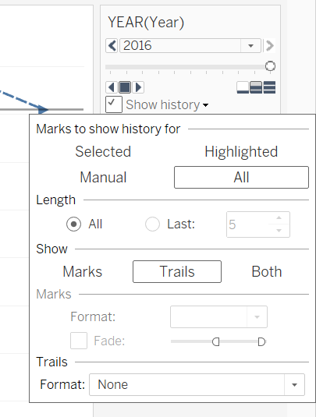

From the Analytics pane, drag and drop the ‘Trend Line’ to Linear.

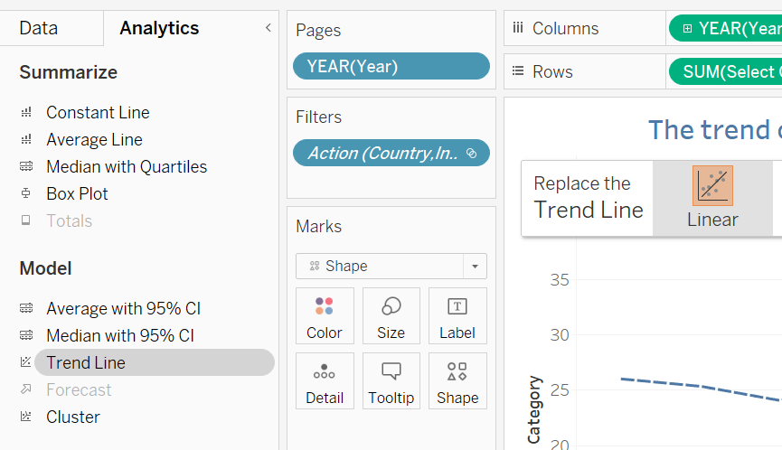

Check the animation.

Step 5:

Create a dashboard.

Select all the relevant sheets and drop on the dashboard.

I have embedded a webpage to the dashboard which displays Wikipedia page of the selected country.

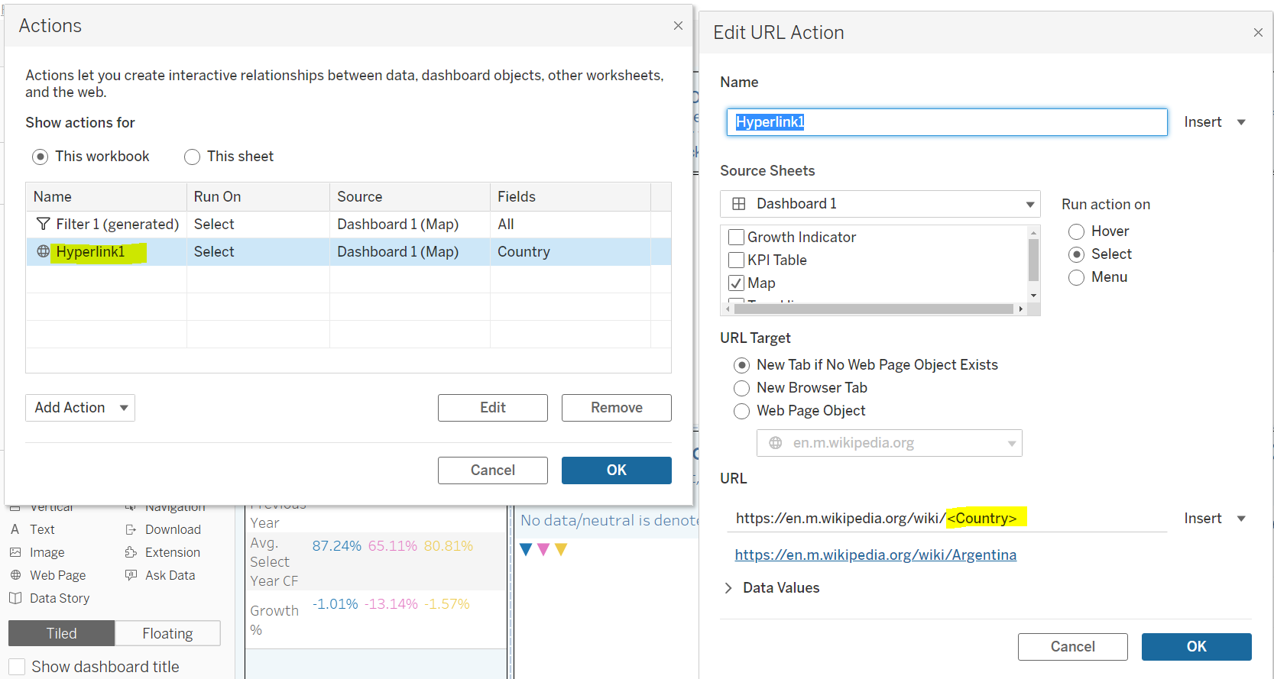

I have provided instructions on my dashboard, so it becomes easier for any person seeing it for the first time.

Eg: ‘Start by clicking on a country in the top left pane, select category and year from the extreme right pane, and view results in the bottom left pane. A trend for the categories can be seen in the bottom right pane. Double-click on the blank space of the map to return to normal.’

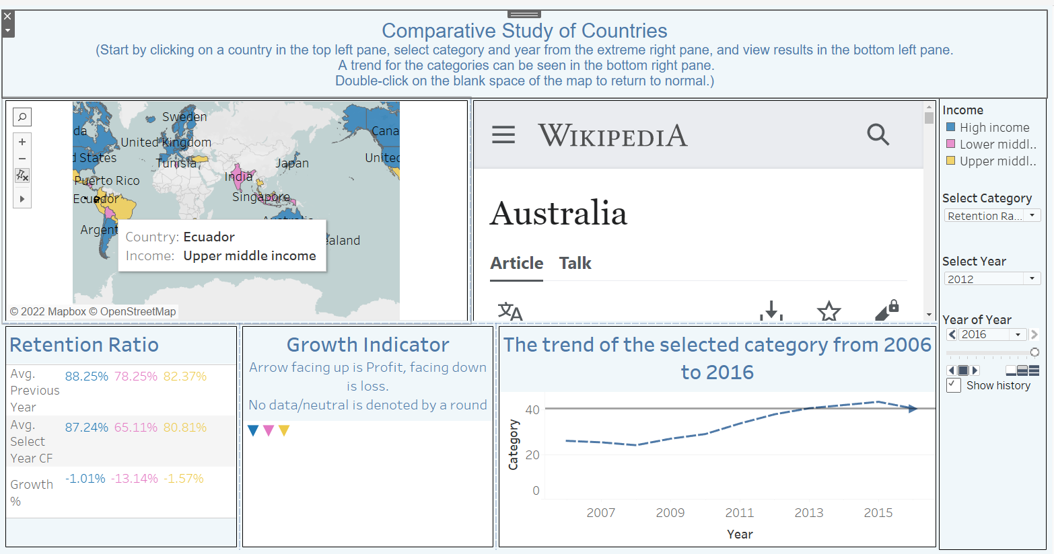

**PROJECT IN BRIEF**:

I have created a dashboard that displays the growth percentage of various parameters such as life insurance share, market share, penetration, the ratio of reinsurance accepted, and retention ratio for the selected year from the previous year. We can get this information for different countries and countries grouped in different income groups.

We can review if the parameters are profitable or in loss as compared to the previous year.

Reviewing this information can help us to strategize market penetration for the products of the insurance company and target new customers**.**